NOTES ON EVALUATION CRITERIA:TEAM DR

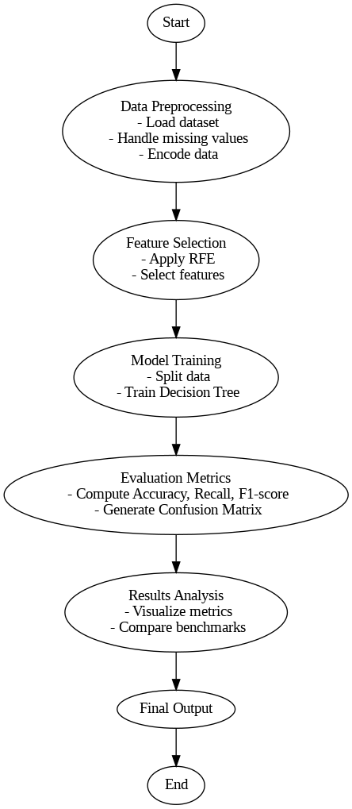

The project involves creating an Intrusion Detection System (IDS) that utilizes a feature selection mechanism to enhance the model's performance. The detailed approach and strategy can be summarized as follows:

**Abstract**

This project focuses on modeling an Intrusion Detection System (IDS) using the NSL-KDD dataset, a popular dataset for network intrusion detection tasks. The process includes several stages of data preprocessing, feature selection, model building, and evaluation. Key stages include transforming categorical features, selecting the most relevant features, and training a decision tree classifier. The model is then evaluated using accuracy scores, recall, F-measure, and confusion matrix, with 10-fold cross-validation to ensure robust performance.

**Project Overview**

**1. Data Preprocessing**

* **Categorical Features Transformation:** All categorical features in the dataset are converted into numerical representations using one-hot encoding to ensure that the data can be used effectively in machine learning algorithms.
* **Scaling Features:** The features are scaled to prevent those with larger values from disproportionately affecting the model’s learning process.

**2. Feature Selection**

* **Univariate Feature Selection (ANOVA F-test):** The relationship between each feature and the target label is analyzed individually using ANOVA F-test. This helps in determining which features are most relevant for the task.
* **SecondPercentile Feature Selection:** The features are ranked based on the scores obtained in the previous step, and a subset of the most relevant features is selected using the SecondPercentile method. This reduces the complexity by eliminating redundant features.
* **Recursive Feature Elimination (RFE):** After the initial feature selection, RFE is applied to recursively eliminate features that are less important for the model’s prediction power. This ensures that only the most informative features are retained.

**3. Model Building**

A **Decision Tree classifier** is chosen for the IDS model. Decision trees are a popular choice for classification tasks because they are interpretable and can handle both categorical and numerical data efficiently. The model is trained using the training dataset after selecting the optimal features.

**4. Model Evaluation and Validation**

The model’s performance is evaluated using multiple metrics:

* **Accuracy Score:** Measures the overall proportion of correct predictions.
* **Recall:** Focuses on the true positive rate to minimize false negatives.
* **F-measure:** Provides a balance between precision and recall.
* **Confusion Matrix:** Helps in visualizing the performance of the model, showing true positives, false positives, true negatives, and false negatives.
* **10-Fold Cross-Validation:** The dataset is split into 10 parts, and the model is trained and tested on each fold to ensure generalizability.

**5. Results and Evaluation**

The evaluation results from the dataset, including the accuracy scores, recall, F-measure, and confusion matrix, will be summarized in the following section after processing the dataset.

**Code Strategy and Implementation**

The code starts by importing necessary libraries like **NumPy**, **Pandas**, **Matplotlib**, **scikit-learn**, and others for preprocessing, feature selection, and model training. Here’s the overall implementation strategy:

1. **Data Preprocessing:**
   * Load the dataset (NSL_KDD_Train.csv).
   * Transform categorical features into numerical ones using one-hot encoding.
   * Scale numerical features to ensure uniformity across the dataset.
2. **Feature Selection:**
   * Apply univariate feature selection (ANOVA F-test) to identify relevant features.
   * Use **RFE** for recursive feature elimination to optimize the feature subset.
3. **Model Training:**
   * Split the data into training and testing sets using train_test_split.
   * Train a **Decision Tree classifier** on the selected features.
4. **Model Evaluation:**
   * Perform predictions using the trained model.
   * Evaluate performance using accuracy, recall, F-measure, and confusion matrix.
   * Conduct 10-fold cross-validation to assess model stability.

**Key Insights**

1. **Data Preprocessing:** The decision to preprocess and scale the features ensures the model can handle varied data types and avoid biases towards certain features with larger numerical values.
2. **Feature Selection:** Using **univariate selection** and **RFE** allows for a more focused approach, removing irrelevant and redundant features. This reduces the complexity of the model and ensures it focuses on the most important features, enhancing performance and efficiency.
3. **Decision Tree Classifier:** The **decision tree** classifier was chosen due to its simplicity, interpretability, and ability to handle both categorical and continuous data. It’s an excellent model for intrusion detection tasks where explainability is critical.
4. **Cross-Validation:** Performing **10-fold cross-validation** ensures that the model is not overfitting to the data and can generalize well to unseen instances.
5. **Evaluation Metrics:** By using multiple evaluation metrics such as accuracy, recall, F-measure, and confusion matrix, the robustness of the model can be thoroughly assessed, ensuring a holistic understanding of its performance.

**Future:**

• **Include Hyperparameter Tuning**: Use **GridSearchCV** or **RandomizedSearchCV** to optimize models.

• **Improve Innovation**: Try ensemble models, custom loss functions, or deep learning architectures like transformers or graph neural networks.

**Conclusion**

The developed Intrusion Detection System, with careful attention to feature selection and robust model evaluation, provides a strong baseline for detecting intrusions in network traffic. The use of decision trees, alongside appropriate data preprocessing and cross-validation techniques, ensures a scalable, interpretable, and effective model.